MODULE 4 – INTRODUCTION TO DBMS

LAB EXERCISES

12. SQL Group By
Lab 1.
Group employees by department and count the number of employees in each department using GROUP BY.
Ans.
1. SELECT dept_id, COUNT(*) AS total_employees FROM employees GROUP BY dept_id;
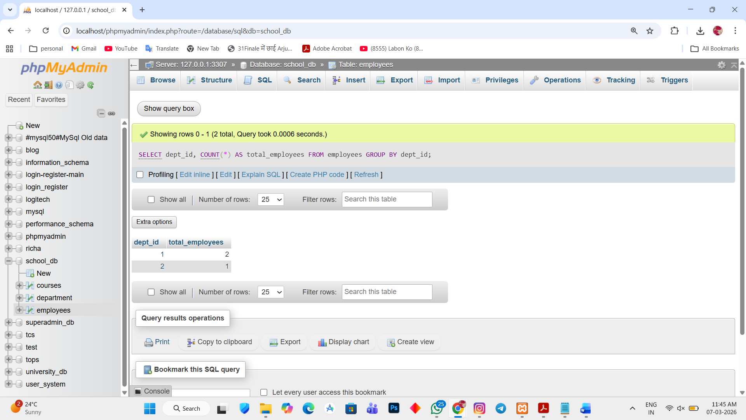

Lab 2.
Use the AVG aggregate function to find the average salary of employees in each department.
Ans.
1. ALTER TABLE employees ADD salary int;
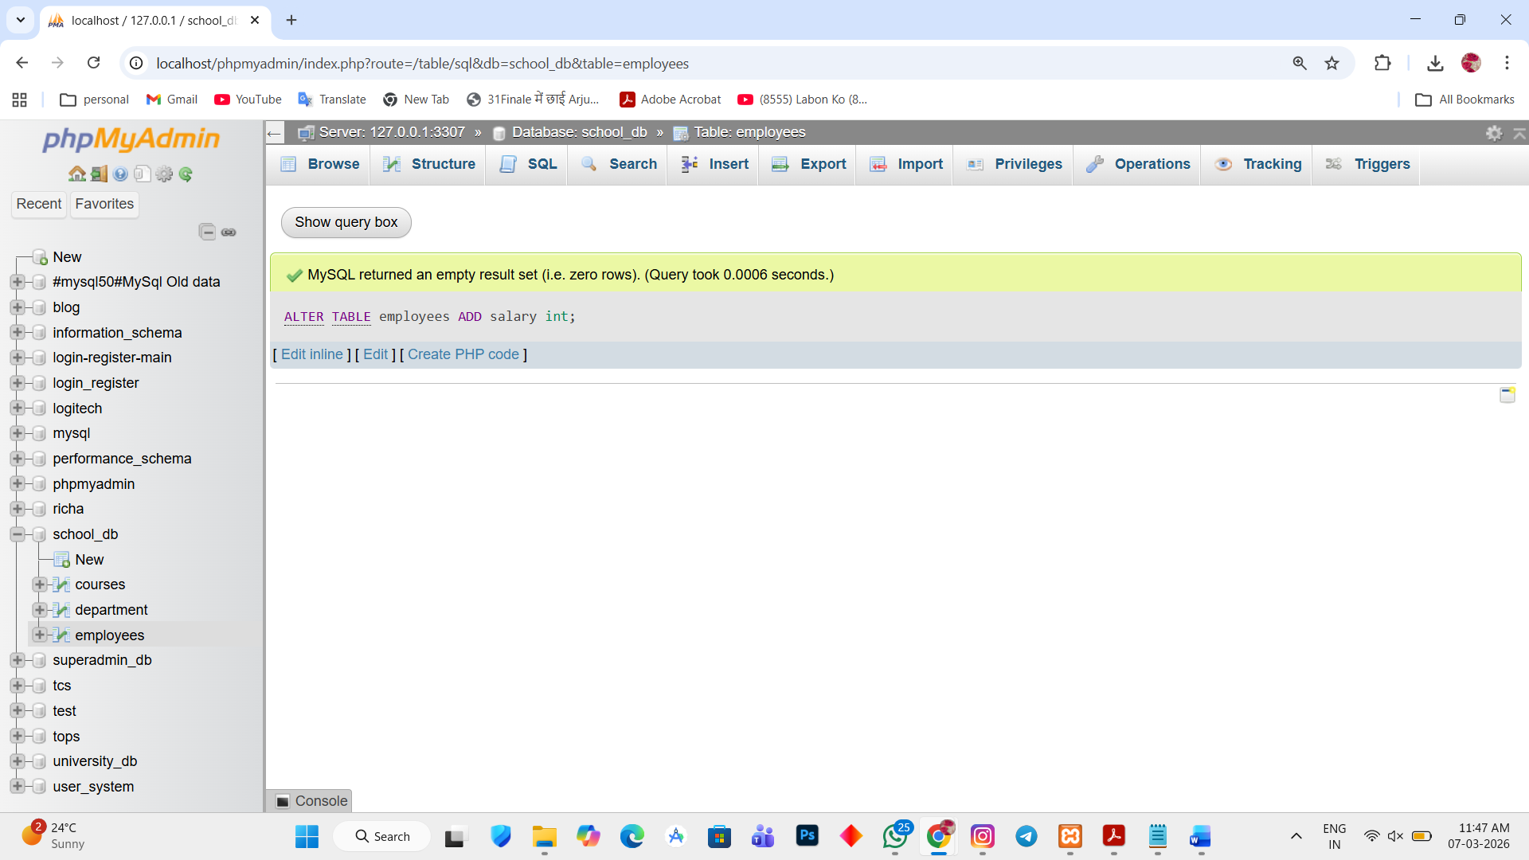

2. update employees set salary = 30000 WHERE emp_id = 1;
update employees set salary = 20000 WHERE emp_id = 2;
update employees set salary = 10000 WHERE emp_id = 3;
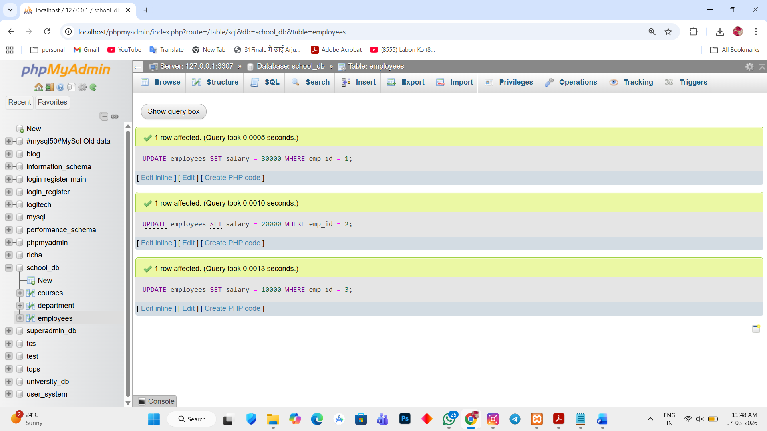

AVG salary in each department
3. SELECT dept_id, AVG(salary) AS average_salary FROM employees GROUP BY dept_id;
